Prevention Plan
Student
Course
Date

The disease that the paper is based on is coronary artery disease. Coronary artery disease is the most common heart disease that kills more than 500,000 people in a year. The disease affects both heart and blood vessels. The disease is highly associated with people's lifestyles. The disease is a major cause of death accounting for more than one-third of all the deaths in a year. The pathophysiology of the disease includes the plaque buildup in the walls of the arteries thus affecting the blood supply to the heart as well as other parts of the body, (Musunuru and Kathiresan, 2019). The plague is caused by the accumulation or deposition of cholesterol and other substances in the artery.
The symptoms of coronary artery disease are closely related to a heart attack. Thus. It's imperative to know how to spot a heart attack. Some of the symptoms of a heart attack include the following. Firstly, if you feel discomfort, pressure, and pain in the center of the chest, (Hajar, 2017). Secondly, if one feels discomfort, tingling, and pain in other parts of the upper body such as stomach, back, arms, and jaws. Other symptoms include vomiting, heartburn, nausea, sweating clammy skin, and shortness of breath. If the symptoms last for more than ten minutes and they keep on coming, it's advisable to call for an ambulance right away. It's not safe to go to the hospital on your own.
The healthy people 2020 goal for people with coronary artery disease is to improve the health of the people as well as the quality of life by detecting, treating, and preventing risk factors that are associated with the disease, (Malakar et al, 2019). The team is also ready to create awareness and test people because early diagnosis and treatment can help in saving people's life. Another goal is to prevent the repeat of coronary artery disease events as a way of reducing the deaths associated with the disease.
The person that I chose to do the risk assessment on is Mr. Martin, (30 years old) who is my friend and a neighbor. Martin is not older than 55 but three family members have been diagnosed with CAD before they were 65 years of age. The blood cholesterol level is 245 milligrams per deciliter (mg/dl). Two years ago, Mr. Martin was diagnosed with high blood pressure. Though he doesn’t have diabetes, Mr. Martin is addict to smoking tobacco. He also lives a sedentary life. According to the risk assessment, Martin is at high risk of getting CAD.
According to the risk assessment carried, Mr. Martin has the following risk factors of getting CAD. In his family, there are three family members with coronary artery disease meaning that he is at high risk of getting CAD. Martin has not taken any care to control the level of cholesterol in the food that he eats. Martin is also obese and has high blood pressure. According to the above risk assessment, Martin is at high risk of getting coronary artery disease and needs to change some ways of living to avoid getting the disease.
In conclusion, CAD is a serious disease that has been killing people all over the world at a very alarming rate. It leads to fracture of the arteries, thrombus, or blood clot. Those under high risk of getting CAD-like Mr. Martin to need to put some measures to reduce their chances of getting the disease. Firstly, eating a balanced diet is very important, (fig. 3). It’s while this sounds like a cliché, it’s a good reason to avoid getting CAD. Replying fully on fat and carbohydrates to carry you out the day can be hard and can induce the body into thinking that you're overeating. Since you're overeating, the body responds by building immunity to insulin which can lead to diabetes and CAD. Exercise is paramount for burning fat, carbohydrates, and sugar in the body (Fig. 2). Moreover, one needs to take a lot of water because most organic compounds that are soluble in water will prevent the plaque from building up (Fig. 1).
Figure 1. Drinking-Water


Figure 2. Exercise


Figure 3. Balanced diet
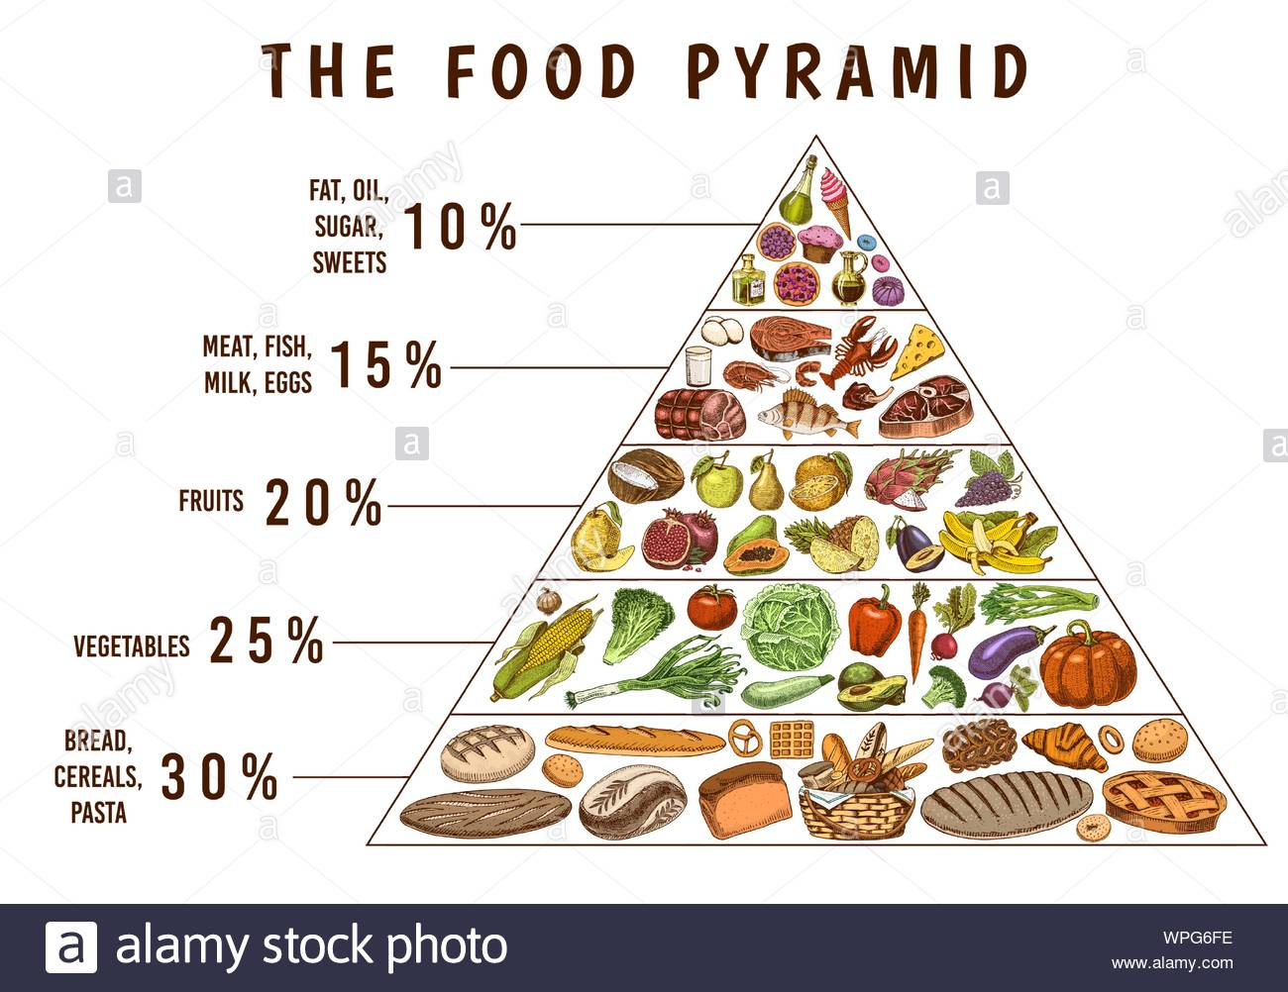

References
Musunuru, K., & Kathiresan, S. (2019). Genetics of common, complex coronary artery disease. Cell, 177(1), 132-145.
Hajar, R. (2017). Risk factors for coronary artery disease: historical perspectives. Heart views: the official journal of the Gulf Heart Association, 18(3), 109.
Malakar, A. K., Choudhury, D., Halder, B., Paul, P., Uddin, A., & Chakraborty, S. (2019). A review on coronary artery disease, its risk factors, and therapeutics. Journal of cellular physiology, 234(10), 16812-16823.
Coronary Artery Picture
